# Name: Mandavi Dubey

Year/Sem: **SE Sem 4**

Div: **A**

# UID No.: 120CP1122B

Roll No.: **23**

* **Experiment No. 3**

**Aim:**

In this experiment the Student will be able to understand the flow of controls and types of loops used in Python programming language with the help of a iterative simulator.

**Platform:**<http://vlabs.iitb.ac.in/vlabs-dev/labs/python-basics/index.html>

**Code & Output:**

# a) FACTORIAL

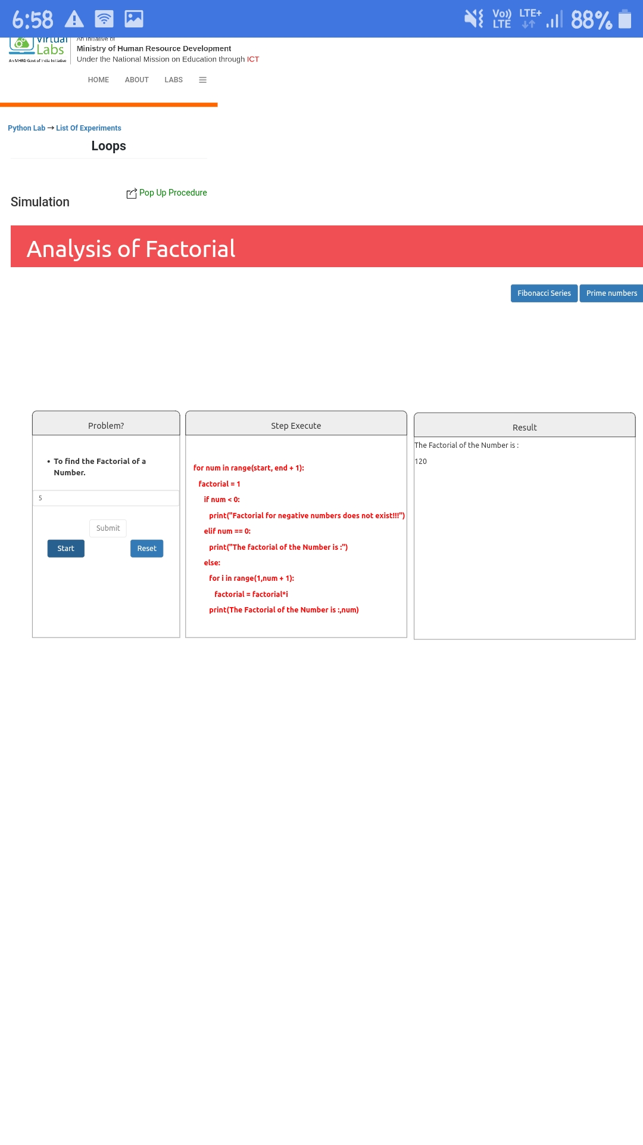

# b) Fibonacci Series

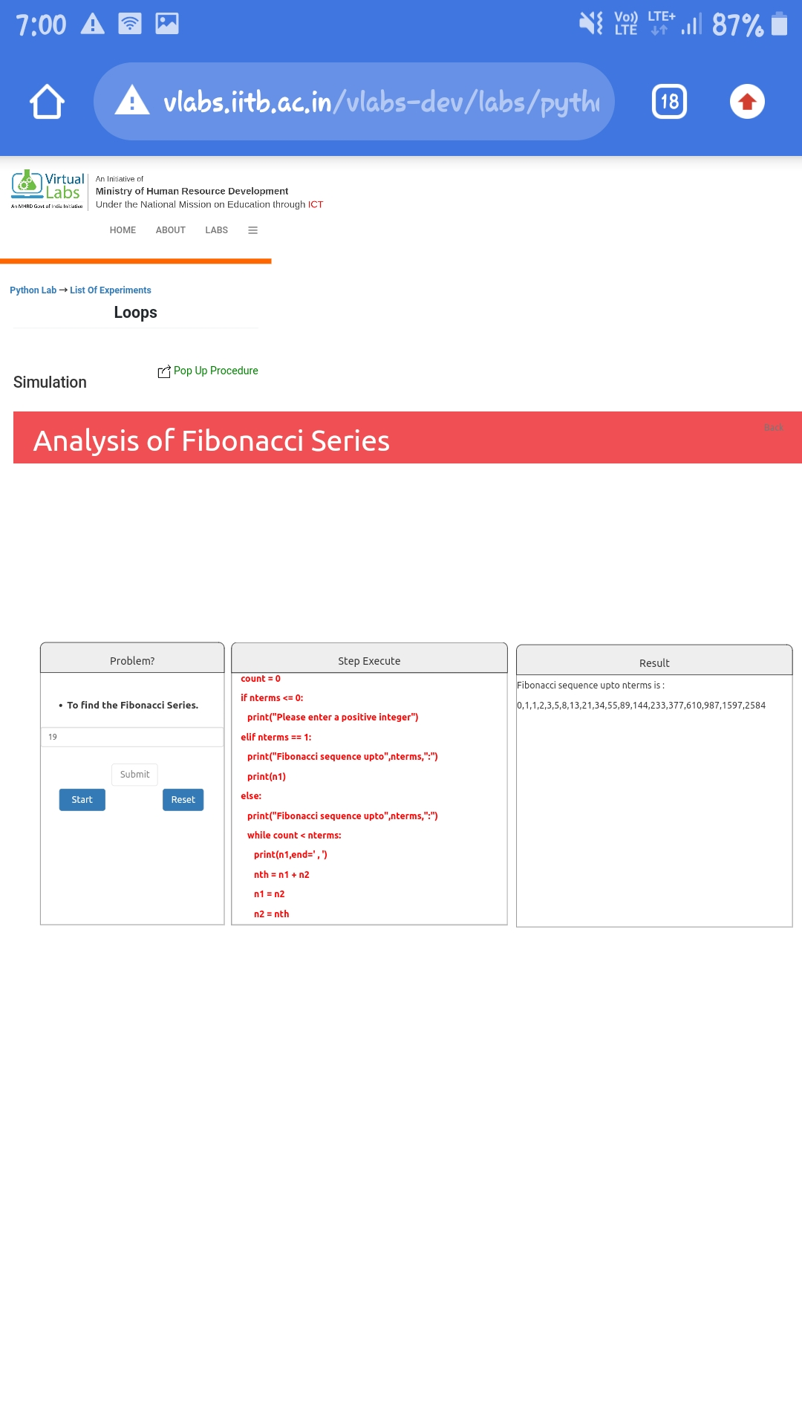

# c) Prime Number :

